**Deadline 2.**

|  |  |  |
| --- | --- | --- |
| **Talabaning HEMIS bo‘yicha o‘rni** | **Talabaning FISH** | **Talabaning guruhi** |
| 8 | Isoqjonov A | 641-23 |

**6-Amaliy ish**

**Mavzu: Razvedka hujumini amalga oshirishni o‘rganish: Tarmoq snifferlaridan foydalanish**

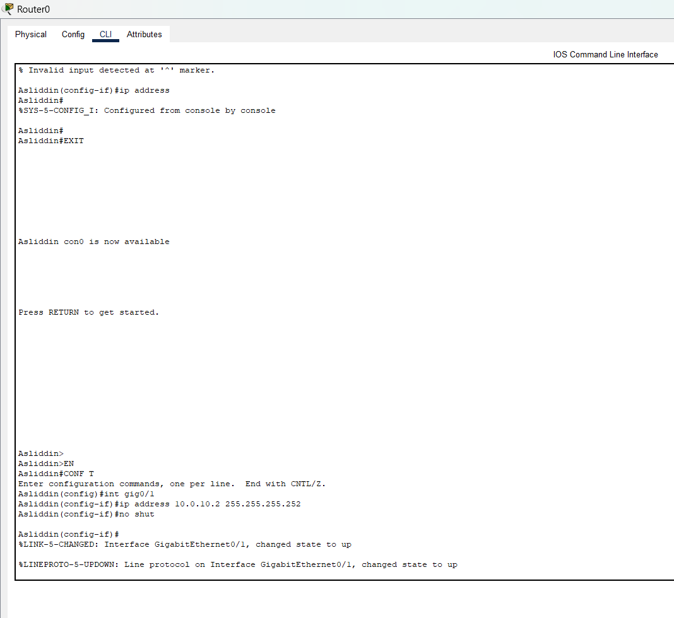

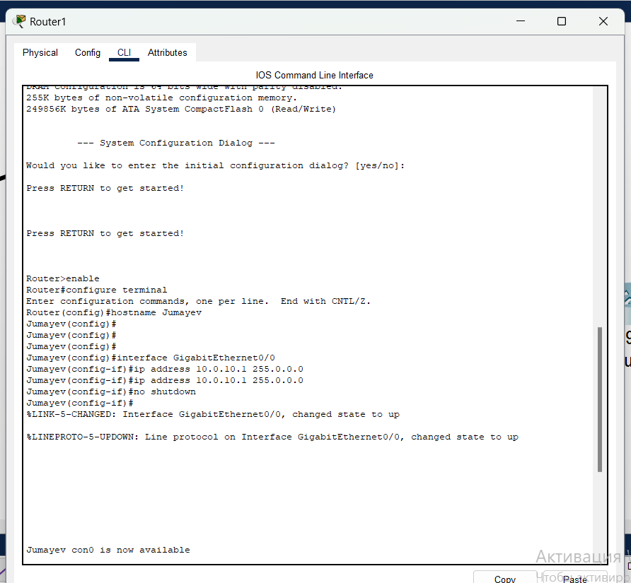

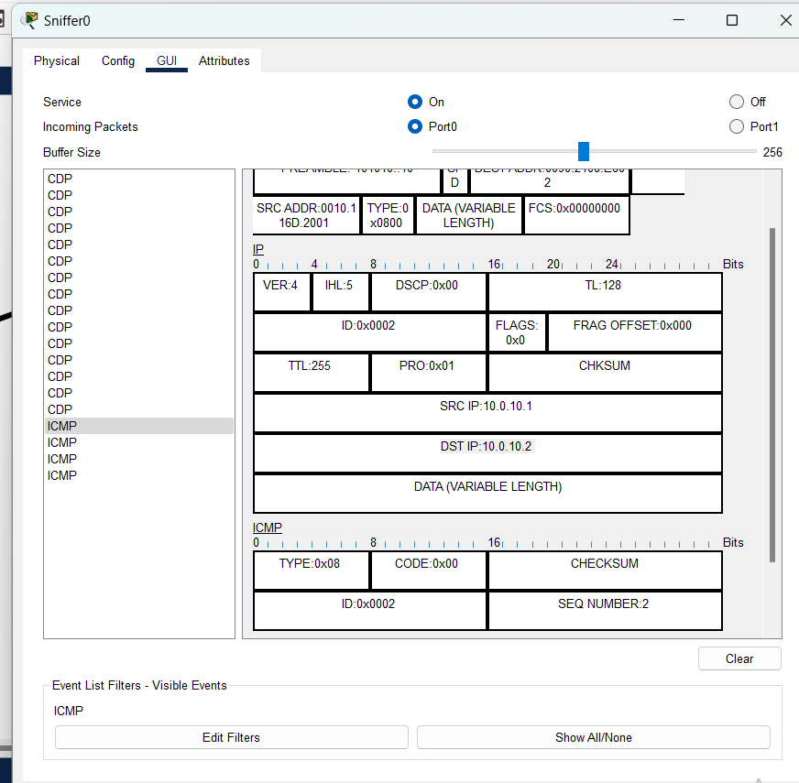

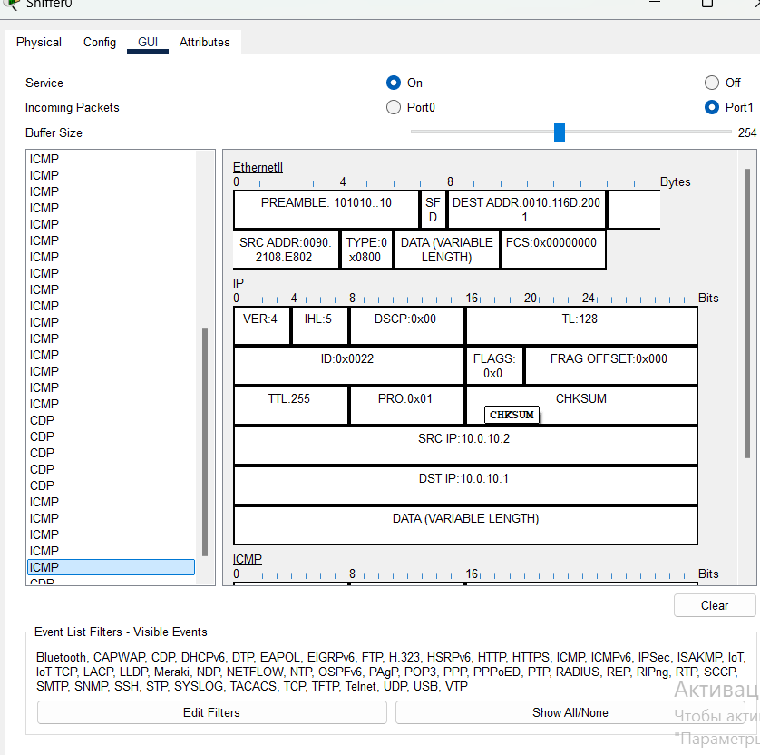

**7-Amaliy ish**

**Mavzu: Tarmoqlararo ekran vositasi yordamida tarmoq himoyasini qurish: Comodo firewall misolida**

Ishdan maqsad: Tarmoqlararo ekran haqida nazariy bilim va amaliy ko’nikmaga ega bo’lish. : COMODO Internet Security Firewall dasturiy ta’minotini kompyuterna o’rnatish va sozlashni o’rganish.

